Research Report
A Rules-Based ETF for Rotating Within the Tech Sector
Ashwin Senthilkumar | MSDS 451 | October 2026
Introduction
Technology is often discussed as if it were one market, but over the past year five well-known tech-focused niche ETFs returned anywhere from about -25% (fintech, FINX) to +43% (cybersecurity, CIBR) (Table 2). Software shows how fast things can turn. IGV was down about 22% over the year amid fears that AI would replace paid software (Roy, 2026). A single broad technology fund hides these differences, while choosing the right niche ahead of time is hard.
My proposal is an actively managed ETF without leverage with the working name Tech Niche Rotation ETF. Each month, it ranks five technology niches (software, fintech, cybersecurity, internet, cloud), invests in up to three of the strongest, and keeps a niche only when its own price trend is positive as well. Leftover funds remain in Treasury bills. The philosophy is mostly technical and active rather than buy-and-hold. I follow relative and absolute price strength instead of valuing individual companies, while the fundamental part is choosing where the AI story is likely to have the largest impact.
Philosophy: Tech isn’t behaving like one unified market anymore. The Tech Niche Rotation ETF invests in the strongest-trading corners of technology (software, fintech, cybersecurity, internet, cloud) and steps into Treasury bills when those trends fade.
This research will help me assess whether a simple, transparent rule can handle tech’s fluctuations better than a broad fund, while also giving me practice building a strategy end-to-end. The intended users are investors who want tech exposure without having to monitor markets every day, as well as any other data science students who can apply the available rules and codes to other sectors.
Literature Review
Is active management successful?
The efficient market’s view holds that prices already reflect available information, meaking past prices should not predict future returns (Fama, 1970). Cornell (2019) points to the Medallion Fund, which earned about 63% annual gross returns from 1988 to 218 (roughly 39% net). However, it trades thousands of short-term positions and is unavailable to outside investors, so it shows that market advantages can exist without proving I can reproduce one.
Fundamental vs. Technical Analysis
Graham (2006) presents the classic case for fundamental analysis, which helps decide what to buy but not when to trade. For timing, Brock, Lakonishok and LeBaron (1992) found that moving-average buy signals on the Dow Jones index from 1897 to 1986 outperformed the sell signals, and Lo, Mamaysky and Wang (2000) found that some chart patterns contain useful information, though both studies examine earlier periods.
Momentum and Trend Following
Relative momentum compares one asset against others. Jegadeesh and Titman (1993) found that past winners kept outperforming over the following 3 to 12 months, while Moskowitz and Grinblatt (1999) found industry momentum to be highly profitable, which fits rotation among tech niches. Absolute momentum, or trend, compares an asset with its past performance. Moskowitz, Ooi and Pedersen (2012) found that 12-month returns forecast next-period returns across 58 futures, and Hurst, Ooi and Pedersen (2017) found profitable trend going back to 1880. Zarattini, Pagani and Wilcox (2025) found long-only trend following on US stocks worked, although turnover made it challenging to implement at a small scale.
Portfolio Construction, Risk, and Automation
Markowitz (1952) explained why diversification matters but mean-variance optimization depends on expected returns that are hard to estimate, so I lean more in favor of Carver’s (2015) volatility-based sizing. For crashes, Greyserman and Kaminski (2014) argue that trend following can deliver “crisis alpha” during extended selloffs, while Krishnan (2017) covers the sell-off strategies, although option hedges come at a cost. Bailey, Borwein, Lopez de Prado and Zhu (2014) warn that testing numerous settings against many settings on the same historical data can inflate backtests, so I plan to use the conventional rules.
Methods
This is the proposed plan, and nothing has been backtested yet. The strategy is mainly technical, long-only and unleveraged, with Treasury bills serving as the defensive holding. Table 1 shows the rules.
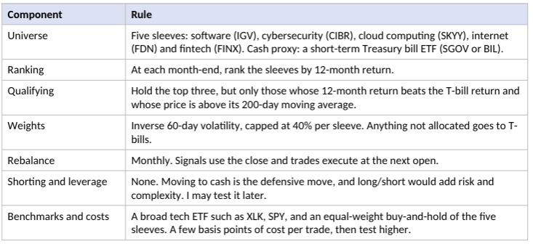
Diversification and Trading Frequency
The fund diversifies across technology niches, but not across other sectors or bonds, and only trades at most monthly. Before testing, I expect annual turnover of roughly 100-300% and about 70-85% of capital invested on average and a larger cash allocation during extended downturns. The ETFs began trading between 2001 and 2016, so a 25-year test is not possible, but a sample starting at 2016 would still include the 2018, 2020, nad 2022 sell-offs, and the most recent 2026 software decline.
Risk, Parameters and Automation
The only hedges are the trend filter, which shifts the fund to cash in downtrends, and the 40% position limit. I chose 12-month and 200-day measures because they are conventional, and I don’t intend to optimize them heavily. Every input is a daily adjusted closing price, a concise Python script that can retrieve prices, calculate returns, rank and filter the ETFs, set capped weights, and output a trade list. These methods are classic time series statistics, and for Checkpoint B I may test whether a regime-switching model performs better than the 200-day filter.
Results
The findings are conceptual so far. The literature suggests using both relative and absolute momentum, using straightforward rules, and accounting for costs and turnover. These points support using ETFs and a monthly schedule. My first review of the five ETFs shows the niche returns are moving apart.
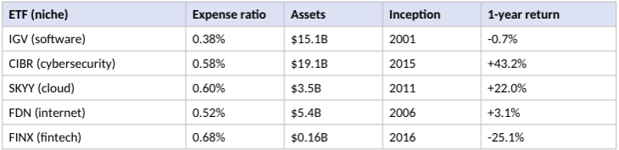
This spread is the case for rotating and influenced several design choices. I included the trend filter because even the best-ranked niche may be falling when the broad sector is. The ETFS also have overlapping holdings. IGV and CIBR both hold Palo Alto Networks and Crowdstrike at roughly 8-9% each, and Cisco and Microsoft appear in two funds, which is one reason for limiting each sleeve to 40%. FINX has only about $160 million in assets, so I may swap that for a larger fund.
Conclusion
Technology is really several distinct markets and deciding which niche to own is a different decision from deciding whether to be invested at all. A long-only strategy that rotates monthly across five tech ETFs looks feasible to build and test using free price data and standard Python tools. My main concerns are that the sleeves share one tech cycle, making diversification less effective than it may appear, and rotation strategies can lose money in unstable markets, such as a single AI-related episode that could distort the backtest. In addition, the ETFs’ fees (0.38-0.68%) would be added to the fund’s own costs, and fund-of-funds restrictions may apply, which I will need to check.
For Checkpoint B, I will download daily adjusted prices, determine whether FINX stays, and implement the rules in code. I will backtest against the benchmarks with transactions costs and report CAGR, Sharpe ratio, maximum drawdown, turnover, and check robustness by changing the lookback periods, number of sleeves and position cap, and splitting the sample in time.

References
Bailey, D. H., Borwein, J. M., Lopez de Prado, M., & Zhu, Q. J. (2014). Pseudo-mathematics and financial charlatanism: The effects of backtest overfitting on out-of-sample performance. Notices of the American Mathematical Society, 61(5), 458-471. https://scholarworks.wmich.edu/math_pubs/40/
Brock, W., Lakonishok, J., & LeBaron, B. (1992). Simple technical trading rules and the stochastic properties of stock returns. Journal of Finance, 47(5), 1731-1764. https://ideas.repec.org/a/bla/jfinan/v47y1992i5p1731-64.html
Carver, R. (2015). Systematic trading: A unique new method for designing trading and investing systems. Harriman House. https://www.harriman-house.com/systematic-trading
Cornell, B. (2019). Medallion Fund: The ultimate counterexample? SSRN. https://papers.ssrn.com/sol3/papers.cfm?abstract_id=3504766
ETFdb. (2026). IGV and FINX fund pages [Data as of October 12, 2026]. https://etfdb.com/etf/IGV/; https://etfdb.com/etf/FINX/
ETF Research Center. (2026). SKYY and FDN fund pages [Performance as of September 30, 2026]. https://www.etfrc.com/SKYY; https://etfrc.com/FDN
Fama, E. F. (1970). Efficient capital markets: A review of theory and empirical work. Journal of Finance, 25(2), 383-417. https://doi.org/10.1111/j.1540-6261.1970.tb00518.x
Graham, B. (2006). The intelligent investor (Rev. ed.). HarperBusiness. https://books.apple.com/us/book/id363689140
Greyserman, A., & Kaminski, K. (2014). Trend following with managed futures: The search for crisis alpha. Wiley. https://www.oreilly.com/library/view/trend-following-with/9781118890974/
Hurst, B., Ooi, Y. H., & Pedersen, L. H. (2017). A century of evidence on trend-following investing. Journal of Portfolio Management, 44(1), 15-29. https://www.aqr.com/Insights/Research/Journal-Article/A-Century-of-Evidence-on-Trend-Following-Investing?aqrPDF=1
Jegadeesh, N., & Titman, S. (1993). Returns to buying winners and selling losers: Implications for stock market efficiency. Journal of Finance, 48(1), 65-91. https://ideas.repec.org/a/bla/jfinan/v48y1993i1p65-91.html
Krishnan, H. (2017). The second leg down: Strategies for profiting after a market sell-off. Wiley. https://wiley-vch.e-bookshelf.de/the-second-leg-down-9563691.html
Lo, A. W., Mamaysky, H., & Wang, J. (2000). Foundations of technical analysis: Computational algorithms, statistical inference, and empirical implementation. Journal of Finance, 55(4), 1705-1765. https://web.mit.edu/~alo/www/Papers/techanal.html
Markowitz, H. (1952). Portfolio selection. Journal of Finance, 7(1), 77-91. https://doi.org/10.1111/j.1540-6261.1952.tb01525.x
Moskowitz, T. J., & Grinblatt, M. (1999). Do industries explain momentum? Journal of Finance, 54(4), 1249-1290. https://ideas.repec.org/a/bla/jfinan/v54y1999i4p1249-1290.html
Moskowitz, T. J., Ooi, Y. H., & Pedersen, L. H. (2012). Time series momentum. Journal of Financial Economics, 104(2), 228-250. https://www.aqr.com/library/journal-articles/time-series-momentum
Roy, S. (2026, February 5). Beaten-down software ETF approaches key support level. ETF.com. https://www.etf.com/sections/features/beaten-down-software-etf-approaches-key-support-level
StockAnalysis. (2026). First Trust NASDAQ Cybersecurity ETF (CIBR) [Data as of October 13, 2026]. https://stockanalysis.com/stocks/cibr/
Zarattini, C., Pagani, A., & Wilcox, C. (2025). Does trend-following still work on stocks? SSRN. https://papers.ssrn.com/sol3/papers.cfm?abstract_id=5084316

